NCSA

ast

connection

|  |
| --- |
| Mock Surgery  If anyone is unaware we did it!! On Wednesday March 29th, we took over the lobby of the legislative building and alongside a very helpful Dr. Shah and many many other helpful people we managed to pull off doing a mock total knee. It was very excited after all the hard work and planning to see something like that get pulled off. Thank you to everyone who helped and come out to show your support for our cause. The number of students and fellow surgical techs that were there supporting us was awesome!! |
|  |
|  |

(Shown in Photo left to right Katie Dowdy, Dr. Shah, Melissa Messina, Courtney Peck, and Heather Burggraf. Not shown Robin Keith and Kristi Pair)

# Hello from the board!!

## (Shown in Photo top row left to right Michelle Gay, Andrea Stokes, Melissa Messina, Brittany Votaw and Jaime Tinsley. Bottom Row left to right Katie Dowdy, Misty Tuttle, Tralanda Davis and Heather Hodges.

# Let’s meet our Board!

### If you missed our last NCSA State Conference which was held in Greenboro, North Carolina March 25th and 26th then you missed a lot. In addition to all the great speakers you missed the election. Where we voted in not only new board members but also a new treasurer, secretary, vice president and a new president! Ms. Heather Hodges or madam President was elected to lead us. Ms. Katie Dowdy was voted in as her vice. Ms. Misty Tuttle was voted into the secretary position. Ms. Jamie Tinsley was voted in as our treasurer. And Michelle Gay, Tralanda Davis, Andrea Stokes, and Brittany Votaw were voted in to be part of our board of directors. Congratulations to all!!!We’re all very excited to see what the next 2 years brings us.

# 

# C:\Users\Melissa\AppData\Local\Microsoft\Windows\INetCache\Content.Word\20170326_142109.jpgmeet our new President Ms. Heather Hodges

I am Heather Hodges. I live in Mooresville, NC with my two children, Hatten and Liam, and my husband, Clark. We have two blue tick hounds, Daisy and Pepper. I graduated in 2011 from Cabarrus College of Health Sciences in Concord, NC. I am employed by CHS-Northeast in Concord as a Certified Surgical Technologist where I am also the General Surgery coordinator. I have been a board member of the NC State Assembly of Surgical Technologists since 2013 and the chair of the legislative committee for NC State Assembly since 2014. I love being a member of the state assembly and all that AST stands for. I look forward to being your voice over the next two years. I want to thank you for the opportunity to be your president. We are going to have a fantastic two years.

# C:\Users\Melissa\AppData\Local\Microsoft\Windows\INetCache\Content.Word\1_20170326_142009.jpgMEET OUR NEW VICE PRESIDENT MS. KATIE DOWDY

Hello, my name is Katie Dowdy and I am from the beautiful beaches of the Outer Banks. I currently hold three certifications Certified Surgical Technologist, Certified Surgical First Assistant, and Certified Surgical Assistant. I am the Neuro Team lead assistant at my facility. I hold each certification to the highest standard. I know what an important part of the TEAM we are and our value in every case. I have been on the board of with NCSA-AST for two terms and have loved every moment of it. Being appointed to the legislative committee has been a wonderful experience and taught me a lot. We have made great advancements on the legislative front and as your new committee chair I look forward to keeping the momentum going.

|  |
| --- |
| CHECK OUT OUR WEBSITE TO STAY UPDATE BY VISITING OUR WEBSITE<http://nc.ast.org/> |

# MEET OUR NEW treasurer MS. jamie tinsley C:\Users\Melissa\AppData\Local\Microsoft\Windows\INetCache\Content.Word\1_20170326_141941.jpg

Hi, my Jamie Tinsley and I am from the Greensboro area. I have been a Surgical Technologist for 19 years and have been certified for the majority of those years. I am the Lead Surgical Technologist for the Urology team at Wesley Long Hospital. I love my job and have never thought twice about my career. I am married with two boys that keep me going when I am not at work. I have severed on the NCSA for the past four years a Board of Director and Vice President. I look forward to serving you as your Treasurer. I look forward to why this year holds for our state!

# meet our new secrity Ms. Misty Tuttle

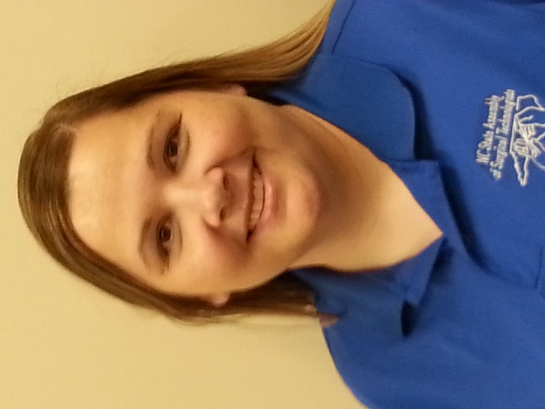My name is Misty Tuttle and I live right outside of Greensboro. I am married and I have an amazing little girl! I have been a certified surgical technologist for 18 years. I graduated with my Associates in Applied Science in 2008. I work for Cone Health on the Wesley Long campus where I am the lead surgical technologist for the general surgery service. In that role, I am a part of leadership, I am a resource for my service, and I precept new employees, RN residents, and students. Those are just a few things that I do as a lead tech!

I have served on the NC State Assembly board for 7 years and I have enjoyed every minute! I love that I get to meet techs that share the same passion about my profession. By serving on the board, I am privileged to be a voice for all techs across this state. Thank you for allowing me to serve as secretary and I look forward to an amazing year!

# Now to meet our Board of Directors

# Ms. Michelle Gay

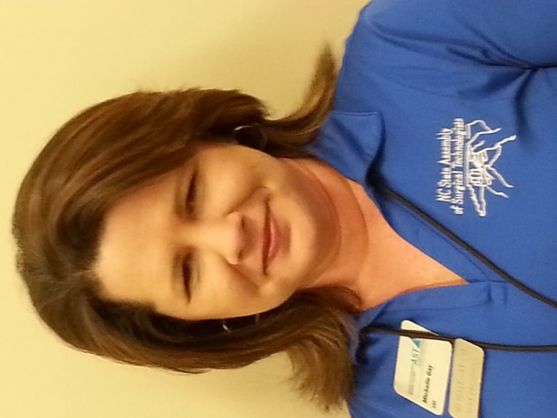Hi, my name is Michelle Gay and I am from the Concord area.  I have been a Certified Surgical Technologist for 16 years.  I received my Associates in Science Degree in Surgical Technology and my Bachelor’s Degree in Health Services Leadership and Management from Cabarrus College of Health Sciences. I am currently a Master’s Degree student at East Carolina University pursuing a degree in Adult Education with an emphasis on Healthcare Adult Education.   Since graduation, I have practiced in local hospitals and educational opportunities with CCHS.  I am not the Program Director for Surgical Technology at CCHS.  I have served on the NCSA Board of Directors for 6 consecutive years and have immensely enjoyed being part of a team that has encouraged education and legislation to its fullest capabilities.   I also serve and currently Chair the Education and Professional Standards Committee for the Association of Surgical Technologists where we develop strategies that enhance education.  I have a passion for surgical technology that I want to share with each and every member as we soar to new heights.  When I am not practicing surgical technology, I enjoy spending time with my family that mostly consist of a baseball field with two incredible boys.  I look forward to continuing to serve the membership as your NCSA AST Board of Director.

# Ms. Melissa Messina

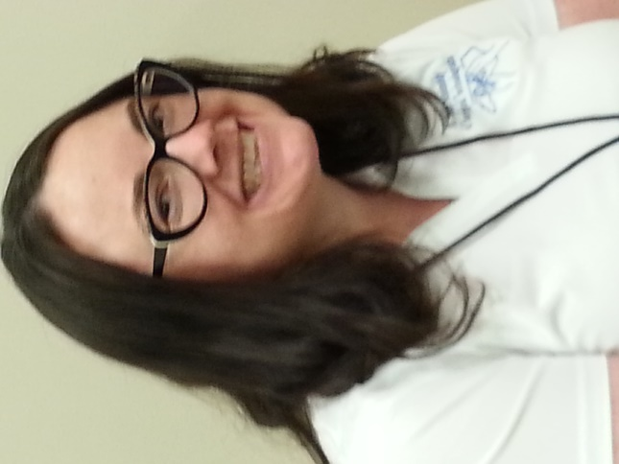Hi, my name is Melissa Messina and I am a Certified Surgical Technologist and I work at Carolinas Healthcare Systems-Cleveland in Shelby North Carolina. I’ve been working at CHS-Cleveland for 5 years, and for the last 2 years I have been the Orthopedic Coordinator. I’m original for Philadelphia and have live in North Carolina for the last 12 years, I have a very awesome 4-year-old son, and yes, I’m aware that I may be a little bias but he rocks!! I’m super excited and honored to be part of your board, Thank you!

# Ms. Tralanda Davis

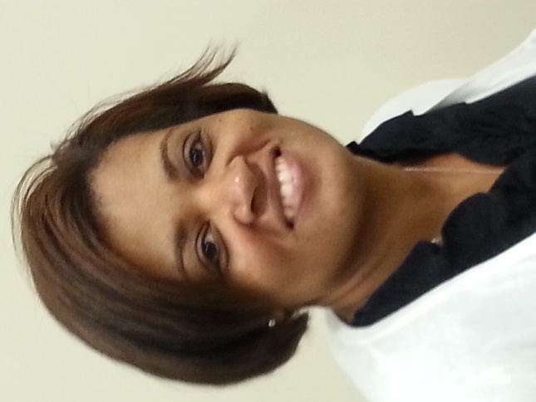Hi, I am Tralanda Davis, I am currently a Program Director at Miller Motte College Cary. I live in the Research/Triangle area. I have been teaching for 10 years and was in the scrub role for 4 years. While in the operating room setting, my specialty was bariatrics and orthopedics, but I also scrubbed in other surgical cases such as cardiovascular, peripheral vascular, ENT and neurology.

I have a Master's degree in Adult Education and Organizational Development and a Bachelor's degree in Liberal Arts and Sociology. I am also a Certified CPR instructor. I absolutely love Surgical Technology and I am so glad I chose this profession over 14 years ago, I love to see students succeed and practicing surgical technologist in the field with leadership roles. This field always seems to amaze me with its everyday changes.

I am so grateful that you chose me as a Board of Director for the North Carolina State Assembly! And I am looking forward to an amazing 2 years.

# Ms. Brittany Votaw

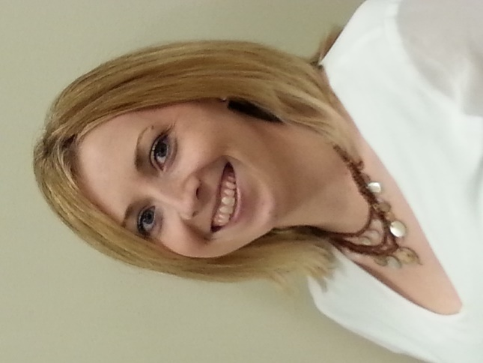Hello, my name is Brittany Votaw and I am from the Charlotte area.  I am currently a lead tech at Carolinas Healthcare System Pineville.  I have been Surgical Technologist for almost 8 years and certified for almost 5.  I am responsible for the orientation of our new staff, coordinator liaison between orthopedics, soft tissue oncology, and plastic/reconstructive surgery at CHS Pineville.  I am a graduate of CPCC with my Associate's Degree in Applied Science.  I was raised in a small town right outside of Charlotte called Waxhaw and I love raising my son in that same small little town.  I absolutely love my profession and what I do every single day.  I am so passionate about this profession and it continues to grow daily.  I love educating new staff and students how vital we are to the operating room and the safety of our patients.  I believe we all make a difference and I am so thrilled to be a part of that.  I am overjoyed to be a part of the NCSA Board of Directors.  It is an honor to sit on a board and association that is truly passionate about our profession.  By serving on this board it gives me a voice for all those fellow techs making this profession better every day.  I am truly honored to be a part of this assembly and board.  Thank you so much for allowing me to be your voice.  I look forward to the next 2 years and all the changes to come.

# C:\Users\Melissa\AppData\Local\Microsoft\Windows\INetCache\Content.Word\20170326_142032.jpgMs andrea Stokes

My name is Andrea Stokes, and I am from the Greensboro area. I graduated in July 2016 from the Surgical Technology Program at Guilford Technical Community College (G.T.C.C.) in Jamestown , N.C. and became a Certified Surgical Technologist after sitting for the N.C. State Board 2 weeks later. I also hold valid licenses in N.C. Emergency Medical Services (EMT) since 2006, Phlebotomist since 2010, and Certified Nurse Assistant II since 2008. I love the medical field and becoming a CST has really been one of my life long dreams. I have worked for Wake Forest  Baptist Hospital in Winston Salem, N.C on the Trauma and Burn team for 6 months, and I currently work at Moses Cone in the main O.R. on various teams such as, General, Orthopedics, ENT, Ophthalmology, and Trauma. In the fall of this year ( 2017) I will be going back to school to obtain my Associates Degree in Applied Science. I am so excited to be a part of NCSA-AST serving on the  Board of Directors. I look forward to representing Surgical Technologist and being a voice an advocate for my fellow Surgical Technologist. I am very excited about the next to years of my term on the Board of Directors and during this time I hope to encourage upcoming students in the Surgical Technology program, as well as current Surgical Techs to become active in the NCSA-AST organization.

|  |
| --- |
| AST's 48th Surgical Technology Conference |

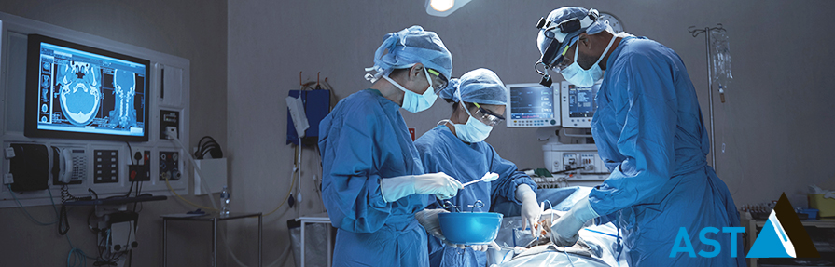



Like us on Facebook

NCSA-AST

|  |
| --- |
| The AST Surgical Technology Conference is the premier surgical technology educational event in the country. It is your once-a-year opportunity to network with nearly 2,000 colleagues and attend educational events specifically targeted to the profession. Almost 100 exhibitors will be demonstrating the latest technology and instrumentation. Nationally recognized healthcare facilities will be onsite to provide career information. Come to the AST Surgical Technology Conference in New Orleans to learn, to network, to enjoy! |

|  |
| --- |
| © 2017 North Carolina  State Assembly of AST  PO Box 298Summerfield, NC 27358-0298 |