
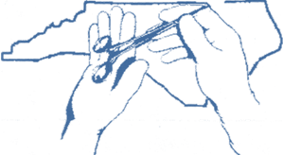NCSA-AST CONNECTION

July 2015
Board Member Message
It’s that time of year again…summer! Adventure time like vacations, trips to the beach and cookouts. But for some of us, it’s mission time.
I’ve been involved with mission work for several years now and this year will make my 4th trip. My goal is to get to every continent that needs help. (Not sure how much help Antarctica needs, but I’m their girl!) This year, it’s back to the Dominican Republic where we will be doing Gynecological surgeries for women who would never otherwise be able to have the needed treatment.
My first mission was a dental trip where I was put in charge of cleaning and sterilizing the necessary instruments. I learned so much about the people of Romania and the needs of that country. I knew I wanted to do more, much more.
Since that first trip, the other missions have been surgical teams. It is truly hard to explain what the impact is for these procedures. The patient is an obvious “winner” in this as the necessary treatment is provided. The patient’s family gets a happy, healthier, productive member of their family back. The host country and my country “win” with forged relationships that are not forgotten. The team “wins” when we are able to perform a top notch surgery sometimes in the most crude, unlikely places with a flashlight and have a successful outcome. As a surgical technologist, I “win” big. Both personally and professionally, I am recognized as a valued team member when only our expertise could make the most impossible seem possible. We can suggest, improvise, multitask, and creatively expand precious resources to the point that we are doing surgery with literally nothing.
As a program director and new Director to the North Carolina State Assembly, I have a new goal. I want to take students on missions and involve as many of our NC members as I can. What better way to prepare a surgical technologist than to illustrate to them the insurmountable need that is in our world and the incredible contribution the skills they now have in their chosen profession can make in this world. If a student can scrub a case in the United States under the absolute best possible circumstances, what a confidence builder it would be to scrub in a Third World nation in a much less “advanced” theater? What we do matters and that is never more evident than on mission.
Please consider a surgical mission for your next summer adventure.
Written By: Suzi Shippen-Wagner
If you are interested, here is more information on AST!
http://www.ast.org/AboutUs/Medical_Missions/

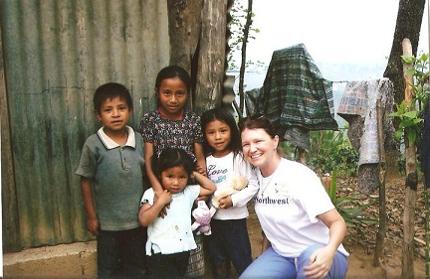

North Carolina
Member Spotlight

My name is Tela Hollowell and I graduated from the College of the Albemarle’s Surgical Technology program in July of 2014. If you asked me a year ago where I thought I would be I would have told you that I saw myself working at a small community hospital, but little did I know that God had other plans for me. A month after I graduated I got a call from Sentara Norfolk General Hospital in Virginia asking for an interview and later a call from them offering me a job! Now almost a year later I couldn’t be happier! I have seen so many things and I’m always learning. Not a day goes by that I don’t learn something new. I do a little bit of everything but my favorite would be neuro.
I was eight years old when my brother was born with Arthrogryposis, a rare congenital condition, and ever since then I knew that I wanted to go into the medical field, but it wasn’t until I was a junior in high school that knew exactly what I wanted to do. At the time, I was competing in medical photography with my high school Health Occupations Students of America (HOSA) club and I had the opportunity to go into the operating room at Vidant Chowan Hospital, one of the local hospitals. I got to spend six hours back there that day taking pictures during two partial knee replacements. When I watched the tech set up for the case and watched what she did throughout the procedure, I fell in love. I knew this is what I wanted to do. I couldn’t ask for a better career to have chosen and I’m blessed to be a part of this amazing profession!

Written by: Tela Hollowell

July 2015

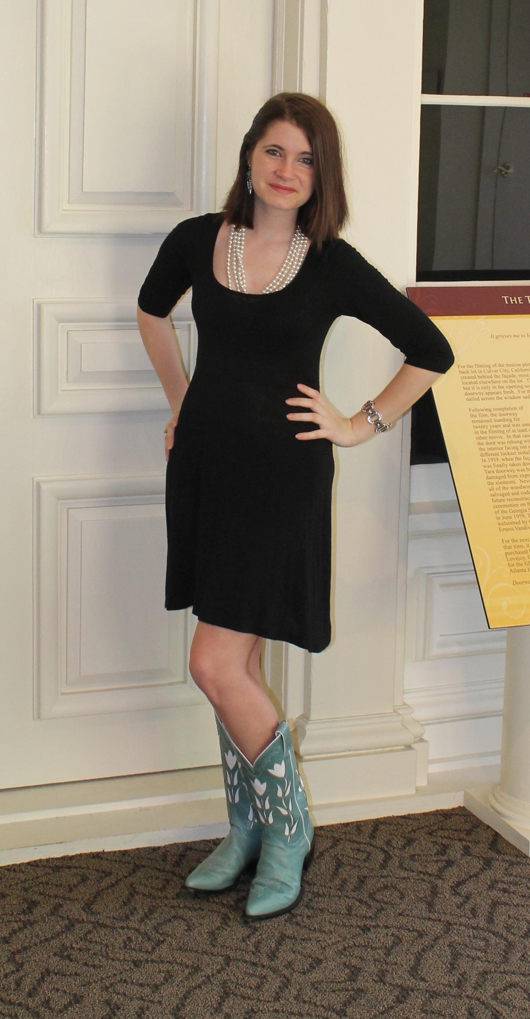
If you are interested in submitting an article for the newsletter please contact us on Facebook or our website!

Don’t forget to celebrate National Surgical Technologist Week!!
September 20th-26th

Nags Head, NC
Save the Date:
Mini workshop is scheduled for September 19th in Nags Head, North Carolina, hope to see you there!

National Conference

Several of the NCSA Board members traveled to San Antonio, Texas for AST's 46th Annual National Conference in May 2015. Each of the board members attended multiple education classes and the State Assembly Leadership Forum. NCSA Board members also got the opportunity to speak to Kathy Sparkman (AST Director of Government Affairs) and discuss NC legislation plans and efforts on mandating certification.
July 2015

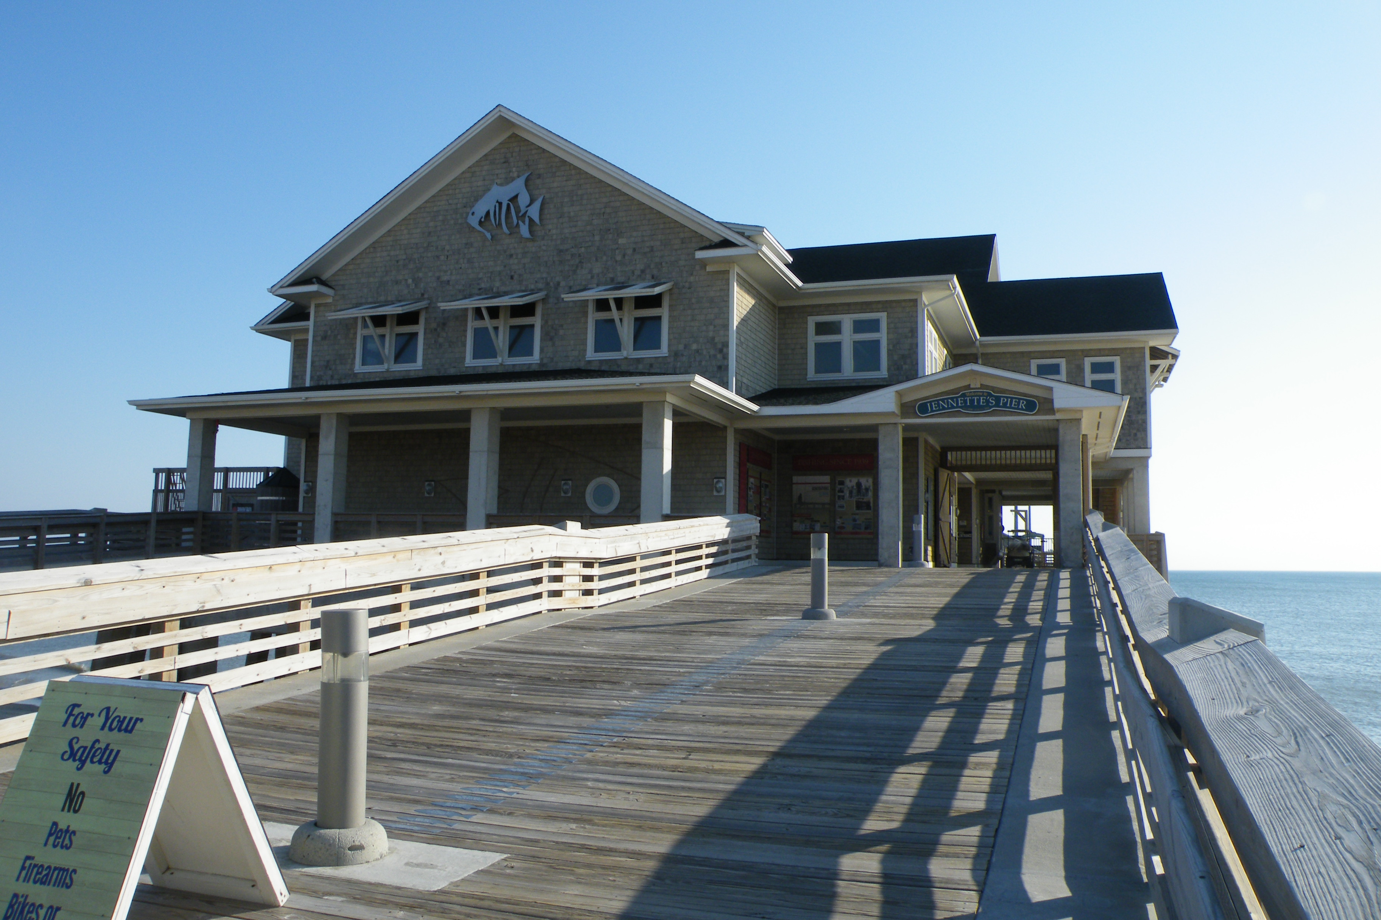
Upcoming
Workshop
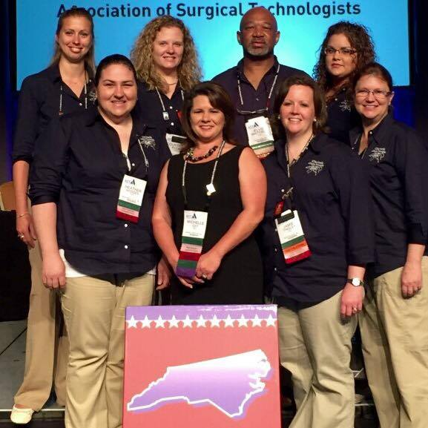
Front row: Heather Hodges, Michelle Gay, Jamie Tinsley, Suzi Shippen-Wagner
Back row: Katie Dowdy, Courtney Peck, Elvis Whitefield Kristi Pair

NCSA-AST FB Page
Get updates on North Carolina State Assembly news and events.
Check out our website for information regarding Surgical Technology.

http://nc.ast.org/

